**Sacramental Program Enrolment Form – (APPLICATIONS CLOSE 31 JANUARY)**

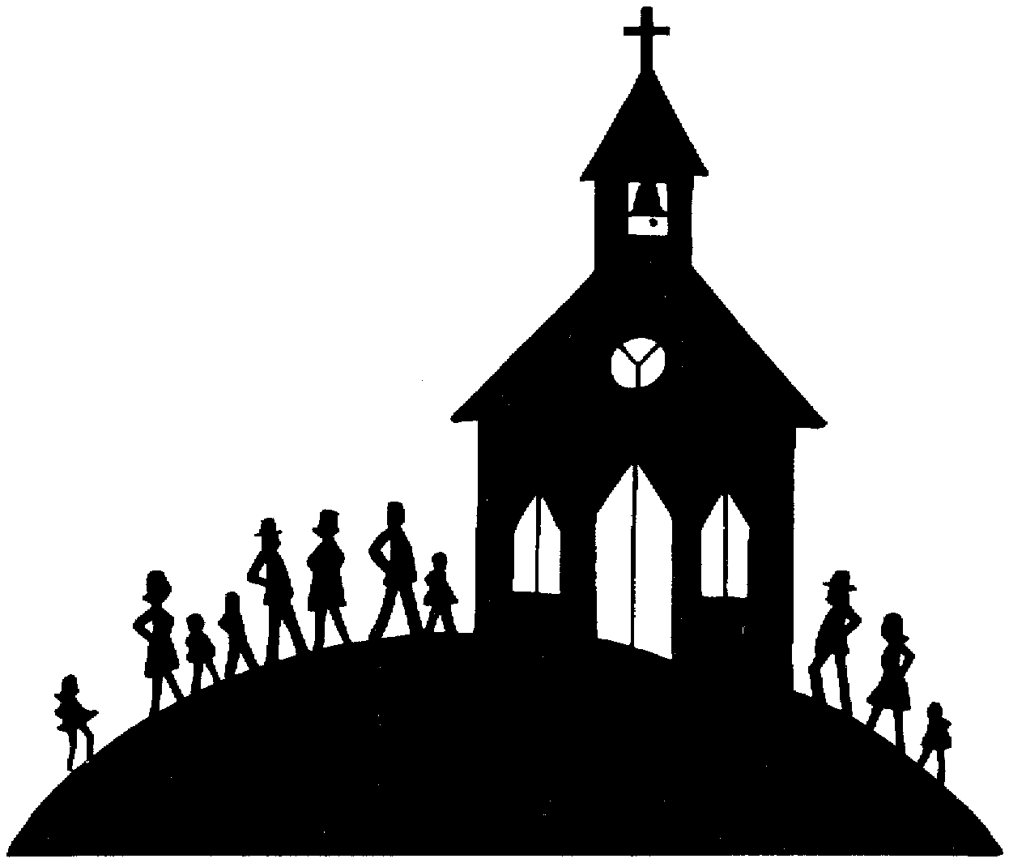

**Insert Psh Logo**

|  |
| --- |
| Child’s Full Name: ___________________________________________________________________________________________  Date of Child’s Birth: _____/_____/_____Date of Child’s Baptism: _____/_____/_____ **Religion** _____________________  Parish / Place of Baptism: ____________________________________________________________ *Attach* **Baptism Certificate**  Has your child already received the Sacrament of **Confirmation**/**Eucharist**/**Penance**? If so, attach a copy of **certificate/s.**  Current school: ________________________________________________ Current school year level: ____________ |
| **Mother’s Information**  Mother’s Full Name: ___________________________________________________________ Religion: __________________  Mother’s Maiden Name: ________________________________________________________  Residential Address: ________________________________________________________________________________________  Contact Number: _____________________________________  Email*:* _______________________________________________________ |
| **Father’s Information**  Father’s Full Name: ___________________________________________________________ Religion: __________________  Residential Address: ________________________________________________________________________________________  Contact Number: _____________________________________  Email: _______________________________________________________ |
| 🞎 Please tick if you are **not** willing to receive future correspondence regarding other events occurring in the parish |
| **Sponsor for Confirmation (MANDATORY) - *Minimum of one Catholic sponsor is necessary for the Sacrament of Confirmation - Sponsor must have received Confirmation, have a copy of certificate, be over the age of 16 years and NOT be the child’s parent.***  **CATHOLIC SPONSOR Name:** _______________________________________________ *Attach* ***Confirmation Certificate***  If missing certificate of sponsor, contact the Parish Office confirmation was made in - provide full name and year of Confirmation they will reprint cert |
| **I hereby give consent for the child to be admitted to the Sacraments of the Catholic Church, I also understand that certain Mass times, liturgies & workshops are live streamed and my child/family may be visible.**  Mother’s Signature: ___________________________________________ Date: _____/_____/_____  Father’s Signature: ___________________________________________ Date: _____/_____/_____  **Family Law Issues *-* Biological Parental Authority for Children to receive the Sacraments**  **IF THIS APPLIES TO YOUR SITUATION THIS MUST BE SIGNED BY BOTH PARENTS AS PER BELOW**  A copy of any Court Orders concerning residence arrangements for the child, time spent by the child with either parent, or parenting issues must be supplied with this enrolment form.  Are there any such Orders? **Yes / No** If ‘Yes’, has a copy of every such Order been attached to this form? **Yes / No**  N.B. While livestreaming and photography does take place, no mention of your child’s name will be made on our social media or website. If GROUP photography is taken, it maybe shared on our Social Media accounts – we will notify the families before the photo is taken and as such it is always optional to be part of the photo. |

**NECESSARY DOCUMENTATION TO BE COMPILED AND RETURNED TOGETHER to** [pa.burleigh@bne.catholic.net.au](mailto:pa.burleigh@bne.catholic.net.au): Incomplete applications and/or missing attachments will not be accepted.

* **ENROLMENT FORM** (filled out)
* CHILD’S **BIRTH CERTIFICATE**
* CHILD’S **BAPTISMAL CERTIFICATE** (plus ANY **OTHER** **SACRAMENTS** if applicable, as listed directly below)
* SPONSOR’S **CONFIRMATION** CERTIFICATE
* **RECEIPT OF CONTRIBUTION**

***Office Use***

|  |  |  |  |  |
| --- | --- | --- | --- | --- |
| **Date of Sacraments** | **Presider** | **Church** | **Date** | **Receipt Number** |
| *Penance* |  |  |  |  |
| *Confirmation* |  |  |  |  |
| *Eucharist* |  |  |  |  |

***Privacy*** The privacy of all individuals is important to the Burleigh Heads Catholic Parish and we are committed to protecting all personal information we collect and hold. Our Privacy Policy is available at www.brisbanecatholic.org.au/privacy-policy/ or on request from the Parish Office.

***Privacy Collection Statement*** The parishes, schools and agencies of the Archdiocese of Brisbane (we, us or our) may collect, use and disclose personal information about you. We collect personal information directly from you and may also collect personal information passively through our website. We collect your personal information to fulfil the mission and directions of our organisation, to administer the sacraments and provide pastoral care to you, to provide you with other services you are seeking, to communicate with you about the services we offer, to solicit donations and to comply with our legal and regulatory requirements. If the personal information you provide is incomplete or inaccurate, we may not be able to provide you with the services or products you seek. We may disclose personal information about you to our parishes, schools and agencies and service providers who assist us in operating our organisation.

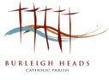

**SACRAMENTAL PROGRAM**



**Inrt Parish Logo**

**ENROLMENT FORM**

*Please read the following information carefully before submitting this form. Readiness of parents to commit to raising their child in the faith of the Church is at the discretion of the Parish Priest in consultation with the Parish Team.*

***Enrolment forms will only be accepted if complete (including certified sponsor)* and returned, compiled together with: sponsor’s Confirmation certificate attached, child’s Birth Certificate, & Baptismal Certificate (and any other sacraments if applicable to your child), together with the receipt of contribution by the due date.**

**Contribution** *Attach:* ***Receipt of Contribution***

* A contribution of $150 ($50 per Sacrament) is asked to cover costs of sacramental resources, and to support the parish.

**Direct Debit Banking details are:**

**BSB:** 064 786 **Ac No.** 100010144 **A/c Name:** Burleigh Parish **Reference**Child’s Surname/Confirmation

  Please provide a copy of your receipt to the Parish Office.

**If you prefer to pay by Credit Card:** Visa / MasterCard

⃣ ⃣ ⃣ ⃣ ⃣ ⃣ ⃣ ⃣ ⃣ ⃣ ⃣ ⃣ ⃣ ⃣ ⃣ ⃣

Exp ……/…… Code __ __ __

Name on card ………………………………………………………………………………...

  Signature …………………………………………………………………….

**Return of paperwork**

* **Please submit this completed enrolment form compiled together with copies of all necessary certificates, and receipt of contribution to:** [pa.burleigh@bne.catholic.net.au](mailto:pa.burleigh@bne.catholic.net.au)
* **If your sponsor has misplaced their Confirmation Certificate, they can contact the Parish Office where the Sacrament was made for a re-print.**
* **If the applicant or sponsor made their sacraments in Burleigh Parish and need a reprinted certificate – full name and date must be provided for a reprint before the application is submitted.**
* **Incomplete (missing attachments) applications will not be accepted.**

**Further details and FAQ’S - https://burleighheadscatholic.com.au/sacramental-program-for-children/**

**Please contact the Parish Office if you have any questions**

*Burleigh Heads Catholic Parish, 3 Sunlight Drive, Burleigh Waters, 4220*

*Office Hours are Monday to Friday 8am – 4pm*

*PO Box 73, Burleigh Heads, Q 4220 Phone: (07) 5558 0120 Email:* [*pa.burleigh@bne.catholic.net.au*](mailto:pa.burleigh@bne.catholic.net.au)

*Website:* [*www.burleighheadscatholic.com.au*](http://www.burleighheadscatholic.com.au)