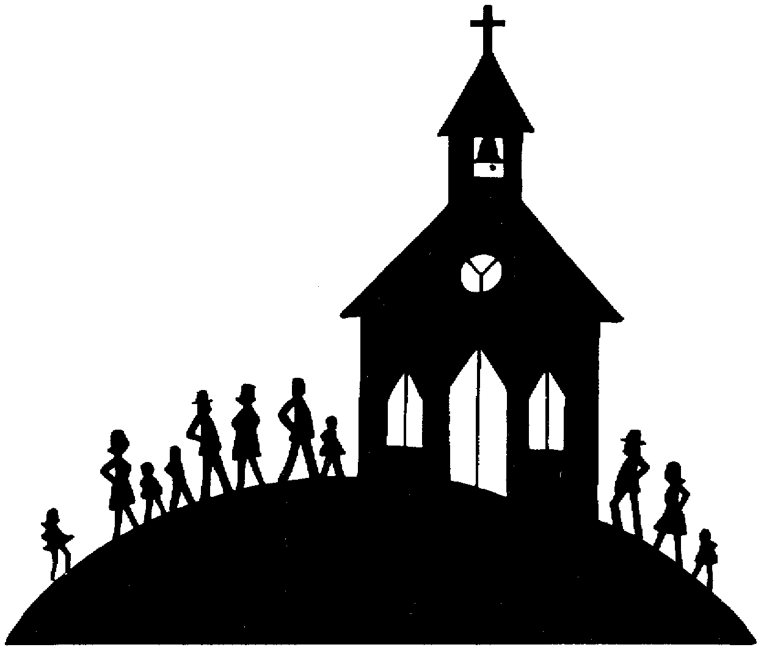 BAPTISM ENROLMENT FORM
Insert Psh Logo
Child’s Full Name: ___________________________________________________________________________________________
Date of Child’s Birth: _____/_____/_____ Place of Child’s Birth: __________________________ Attach Copy of Birth Certificate
Mother’s Information
Mother’s Full Name: ____________________________________________________ Religion: __________________
Mother’s Maiden Name: ____________________________________________________
Residential Address: ________________________________________________________________________________________
Contact Number: _____________________________________
Email: _______________________________________________________
Father’s Information
Father’s Full Name: _______________________________________________________ Religion: __________________
Residential Address: ________________________________________________________________________________________
Contact Number: _____________________________________
Email: _______________________________________________________
Please tick if you are not willing to receive future correspondence regarding other events occurring in the parish

SPONSORS
At least (1) fully initiated Catholic Godparent is necessary and Confirmation Certificate attached, other Catholic Godparents must have Baptism Certificate Attached. Any Christian Witness nominated must be baptised into a recognised mainstream Christian Church and Certificate attached.
CATHOLIC GODPARENT (aged 16 years +) Name: _______________________________________ Attach Confirmation Certificate
CATHOLIC GODPARENT (aged 16 years +) Name: ______________________________________ Attach Confirmation or Baptism Certificate
CATHOLIC GODPARENT (aged 16 years +) Name: ______________________________________ Attach Confirmation or Baptism Certificate
CATHOLIC GODPARENT (aged 16 years +) Name: ______________________________________ Attach Confirmation or Baptism Certificate
CHRISTIAN WITNESS [If baptised other Christian] Name: ___________________________ Church: _______________ Attach Baptism Certificate
CHRISTIAN WITNESS [If baptised other Christian] Name: ___________________________ Church: _______________ Attach Baptism Certificate
I hereby give consent for the child to be admitted to the Sacraments of the Catholic Church
Mother’s Signature: ___________________________________________ Date: _____/_____/_____
Father’s Signature: ___________________________________________ Date: _____/_____/_____

Family Law Issues - Biological Parental Authority for Children to receive the Sacraments

IF THIS APPLIES TO YOUR SITUATION THIS MUST BE SIGNED BY BOTH PARENTS AS PER ABOVE
A copy of any Court Orders concerning residence arrangements for the child, time spent by the child with either parent, or parenting issues must be supplied with this enrolment form.
Are there any such Orders? Yes / No If ‘Yes’, has a copy of every such Order been attached to this form? Yes / No

NECESSARY DOCUMENTATION TO BE COMPILED AND RETURNED TOGETHER (pa.burleigh@bne.catholic.net.au):

- ENROLMENT FORM (filled out)
- CHILD’S BIRTH CERTIFICATE
- ALL LISTED GODPARENT’S CONFIRMATION CERTIFICATE(S)
- ALL LISTED CHRISTIAN WITNESS’ BAPTISM CERTIFICATE(S)
- PROOF OF PAYMENT OF CONTRIBUTION

[OFFICE USE ONLY]
Baptism Prep Meeting |  |  | Date of Baptism | Church |  |  |  |  | Time | Contribution Received
Date: |  | Confirmation Email Sent
Register: |  |  |  |  | PACS:

Privacy The privacy of all individuals is important to the Burleigh Heads Catholic Parish and we are committed to protecting all personal information we collect and hold. Our Privacy Policy is available at www.burleighheadscatholic.com.au or on request from the Parish Office.

Privacy Collection Statement The parishes, schools and agencies of the Archdiocese of Brisbane (we, us or our) may collect, use and disclose personal information about you. We collect personal information directly from you and may also collect personal information passively through our website. We collect your personal information to fulfil the mission and directions of our organisation, to administer the sacraments and provide pastoral care to you, to provide you with other services you are seeking, to communicate with you about the services we offer, to solicit donations and to comply with our legal and regulatory requirements. If the personal information you provide is incomplete or inaccurate, we may not be able to provide you with the services or products you seek. We may disclose personal information about you to our parishes, schools and agencies and service providers who assist us in operating our organisation.

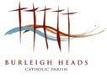
BAPTISM ENROLMENT FORM
Inrt Parish Logo

This process follows the Rite of Baptism for Children and the Sacramental Policy of the Archdiocese of Brisbane.

Please read the following information carefully before submitting this form. Readiness of parents to commit to raising their child in the faith of the Church is at the discretion of the Parish Priest in consultation with the Parish Team.

Contribution Attach Receipt of Contribution
- A contribution of $100 is asked to cover cost of administration and operation of the parish.
- For two children the contribution is $150 for both children.

Direct Debit Banking details are:
BSB: 064 786 Ac No. 100010144 A/c Name: Burleigh Parish Reference Child’s Surname/Baptism
Please provide a copy of the Proof of Payment to the Parish Office.

If you prefer to pay by Credit Card: Visa / MasterCard
⃣ ⃣ ⃣ ⃣ ⃣ ⃣ ⃣ ⃣ ⃣ ⃣ ⃣ ⃣ ⃣ ⃣ ⃣ ⃣
Exp ……/…… Code __ __ __
Name on card ………………………………………………………………………………...
Signature …………………………………………………………………….

Return of paperwork

- Please submit this completed enrolment form compiled together with copies of all necessary documents, and proof of payment of contribution to: pa.burleigh@bne.catholic.net.au

Next Step
- Parent’s Baptism Preparation Session/ or, child-age equivalent preparation, is necessary to complete following the submission of this form, and prior to booking your child’s baptism. Once all forms are received this meeting can be organised. At this meeting the date of Baptism will be confirmed.

Please contact the Parish Office if you have any questions
Burleigh Heads Catholic Parish, 3 Sunlight Drive, Burleigh Waters, 4220
Office Hours are Monday to Friday 8am – 4pm
PO Box 73, Burleigh Heads, Q 4220 Phone: (07) 5576 6466 Email: pa.burleigh@bne.catholic.net.au
Website: www.burleighheadscatholic.com.au

